History


Items highlighted in yellow are tasks for you to complete
Items in Blue italics are help tips

Life in the 1500's

Most people got married in June because they took their yearly bath in May and were still smelling pretty good by June. However, they were starting to smell, so brides carried a bouquet of flowers to hide the body odour (b.o.)

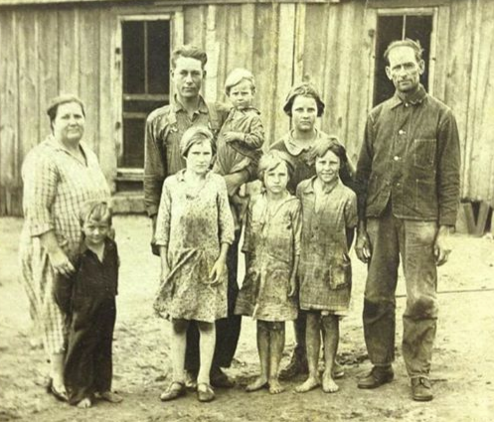

Baths equalled a big tub filled with hot water. The man of the house had the privilege of the nice clean water, then all the other sons and men, then the women and finally the children. Last of all the babies. By then the water was so dirty you could actually lose someone in it. Hence the saying, "Don't throw the baby out with the bath water".
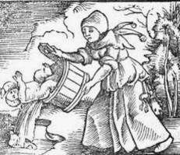

"Don't throw the baby out with the bathwater" is an idiomatic expression for an avoidable error in which something good is eliminated when trying to get rid of something bad, or in other words, rejecting the favorable along with the unfavorable.

'Throw the baby out with the bathwater' is a German proverb and the earliest printed reference to it, in Thomas Murner's satirical work Narrenbeschwörung (Appeal to Fools), dates from 1512. “

Houses had thatched roofs. Thick straw, piled high, with no wood
underneath. It was the only place for animals to get warm, so all the pets... dogs, cats and other small animals, mice, rats, bugs lived in the roof. When it rained it became slippery and sometimes the animals would slip and fall off the roof. Hence the saying, "It's raining cats and dogs."

The phrase is supposed to have originated in England in the 17th century. City streets were then filthy and heavy rain would occasionally carry along dead animals. Richard Brome's The City Witt, 1652 has the line 'It shall rain dogs and polecats'. Also, cats and dogs both have ancient associations with bad weather.

Metaphor
"Raining cats and dogs" literally means that small animals are falling out of the sky. But, of course, this image of animals falling from the sky is a metaphor for very large, heavy drops of water (and possibly dark skies, since animals are opaque). The phrase is not an idiom, as the other answers misinform you.

There was nothing to stop things from falling into the house. This posed a real problem in the bedroom where bugs and other droppings could really mess
up your nice clean bed. So, they found if they made beds with big posts and hung a sheet over the top, it addressed that problem. Hence those beautiful big 4 poster beds with canopies.
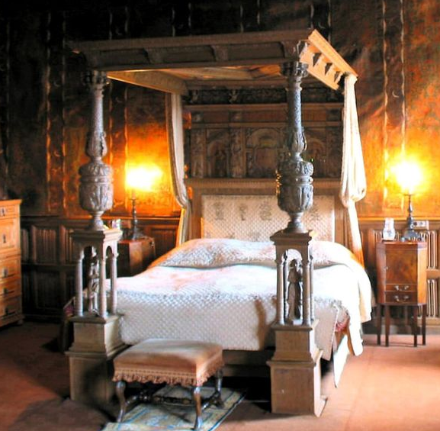
Before they discovered a four-poster bed, English aristocrats had slept on boards set to trestles, with mattresses placed on top of the boards.

The early four-poster beds were very simple in design. Originally, all beds comprised of hard boards covered in fur or quilts. The canopy was added to the bed around the 13th century. This was not attached to the bed but suspended from the ceiling. The four-poster bed was born when the side curtains supported by beams were added to the bed frame. The reason behind this was purely practical – warmth. We know that the castles were not exactly warm, and the bedchambers were often draughty. In addition, the curtains added privacy as the servants often slept in the masters’ bedrooms.

The Plague
Ring Around the Rosie refers to the Black Death?

FitzGerald states emphatically that this rhyme arose from the Great Plague, an outbreak of pneumonic plague that affected London in the year 1665:

Ring-a-Ring-a-Roses is all about the Great Plague; the apparent whimsy being a foil for one of London’s most atavistic dreads (thanks to the Black Death). The fatalism of the rhyme is brutal: the roses are a euphemism for deadly rashes, the posies a supposed preventative measure; the a-tishoos pertain to sneezing symptoms, and the implication of everyone falling down is, well, death.

The floor was dirt. Only the wealthy had something other than dirt, hence the saying "dirt poor." The wealthy had slate floors which would get slippery in the winter when wet. So they spread thresh on the floor to help keep their footing. As the winter wore on they kept adding more thresh until when you opened the door it would all start slipping outside. A piece of wood was placed at the entry way, hence a "thresh hold".

I suspect that instead of mats in doorways, to clean footwear before entering, the entrance to a doorway would have an area outside it with threshings strewn on the ground to act as a doormat. And they would have been held in some kind of shallow containment. Hence a thresh-holder in a doorway.

Sometimes they could obtain pork and would feel really special when that happened. When company came over, they would bring out some bacon and hang it to show it off. It was a sign of wealth and that a man "could really bring home the bacon." They would cut off a little to share with guests and would all sit around and "chew the fat."

Chew the fat. Was originally about grumbling and complaining in later life it move to a conversation, it often did not refer to Bacon but soldiers chewing the fat paper cartidge holders or Indians chewing animal hides.

Those with money had plates made of pewter. Food with a high acid content caused some of the lead to leach onto the food. This happened most often with tomatoes, so they stopped eating tomatoes... for 400 years.

Most people didn't have pewter plates, but had trenchers - a piece of wood with the middle scooped out like a bowl. Trenchers were never washed and a lot of times worms got into the wood. After eating off wormy trenchers, they would get "trench mouth."

During World War I, soldiers were exposed to brutal conditions and often went without medical or dental care. Many soldiers spent months on end living in trenches that were dug into the earth, exposed to the elements and lacking proper military equipment, let alone toothbrushes and toothpaste. As a result of their terrible surroundings, their health suffered and many soldiers developed trench mouth—known officially as Vincent stomatitis or necrotizing ulcerative gingivitis—because of their inability to care for their teeth.
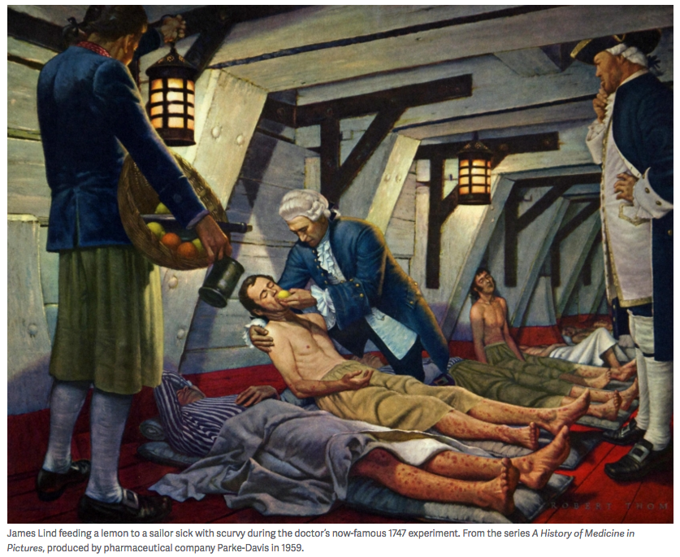
The major mouth illness in 16th Century was Scurvy

Lind was a Scottish physician who served as a naval surgeon on the British ship the HMSSalisbury in 1747 and devised what is considered to be one of the world’s first controlled experiments. He took 12 sailors who were similarly sick with scurvy and divided them into six pairs. All the men ate the same food and lived in the same quarters on the ship; the only difference was their treatment. Lind gave each pair various daily doses of one of six supposed scurvy cures: a quart of hard cider, 25 drops of vitriol, two spoonfuls of vinegar, a half pint of seawater, two oranges and one lemon, and an “electuary”—a creative mix of garlic, mustard seed, balsam of Peru, dried radish root, and gum myrrh, shaped into a pasty concoction the size of a nutmeg. (Lest that treatment not sound random enough, those sailors also got barley water treated with tamarinds and an occasional laxative dose of cream of tartar.) With the exception of the citrus fruit, which ran out in less than a week, Lind administered the treatments for 14 days.

https://www.sciencehistory.org/distillations/the-age-of-scurvy

Bread was divided according to status. Workers got the burnt bottom of the loaf, the family got the middle, and guests got the top, or the "uppercrust".

Lead cups were used to drink ale or whisky. The combination would sometimes knock them out for a couple of days. Someone walking along the road would take them for dead and prepare them for burial. They were laid out on The kitchen table for a couple of days and the family would gather around and eat and drink and wait and see if they would wake up. Hence the custom of holding a "wake".

England is old and small, and they started running out of places to bury people. So, they would dig up coffins and would take their bones to a house and re-use the grave. In reopening these coffins, one out of 25 coffins were found to have scratch marks on the inside and they realised they had been burying people alive. So they thought they would tie a string on their wrist and lead it through the coffin and up through the ground and tie it to a bell. Someone would have to sit out in the graveyard all night to Listen for the bell. Hence on the "graveyard shift" they would know that someone was "saved by the bell" or he was a "dead ringer".


Need help just ask

